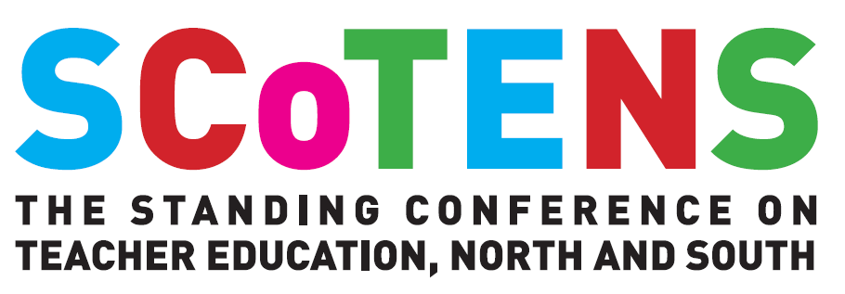

PROPOSAL TO PRESENT A PAPER

SCoTENS CONFERENCE 2020

Slieve Russell Hotel, Ballyconnell, Co. Cavan

Thursday 22nd and Friday 23rd October 2020

Please complete and return to Tricia Kelly at tricia.kelly@qub.ac.uk by 4pm Thursday 11th June 2020

NOTE: Please ensure the details below are accurate. These details in the box directly below will appear in the SCoTENS Book of Abstracts if your proposal is successful.
Title of Paper :
Name of Author(s):
Institutional Affiliation of each author:
Biographical details:
(3 sentences maximum)
Email(s):
Abstract
(max. 400 words)

Name of corresponding author:
Contact telephone number of corresponding author:
Contact Email address of corresponding author:
Paper status:  (please indicate by double-clicking on the appropriate box and selecting Default Value; Checked on pop-up menu ) | Published research  Research in Progress  Postgraduate research in progress
If the Research has been funded, please indicate the funding source
Technical requirements:
(see technical note below)

Technical issues: Each meeting room will be equipped with projector and PC laptop with MS Office Suite. If you wish to use your own PC or Mac laptop you will need to connect it to the LCD projector – please ensure you bring the necessary connections where required. Prezi and other formats can be used. However, although our laptops are wireless enabled, we strongly advise against relying on an internet connection for a presentation since you may not be able to reliably connect to a cloud-based service from the session room.

